**Android System：**

Transfer the file keyes wifi.apk to your cellphone or ipad. Click **keyes wifi.apk** to install.

Click“**ALLOW**”and“**INSTALL**”

After installing, click“**OPEN**”to check the main page of app

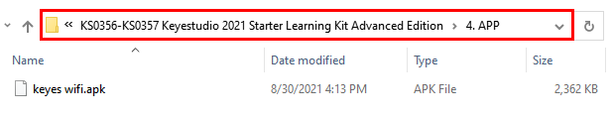



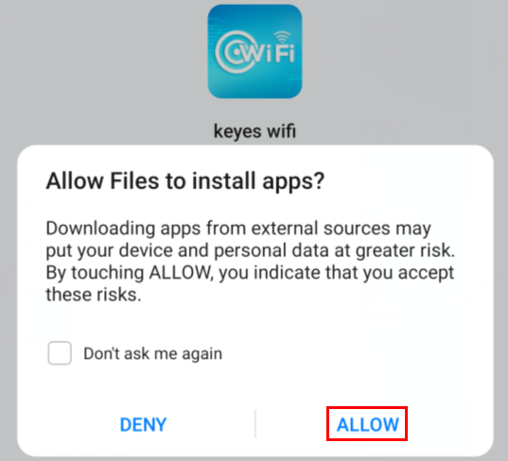

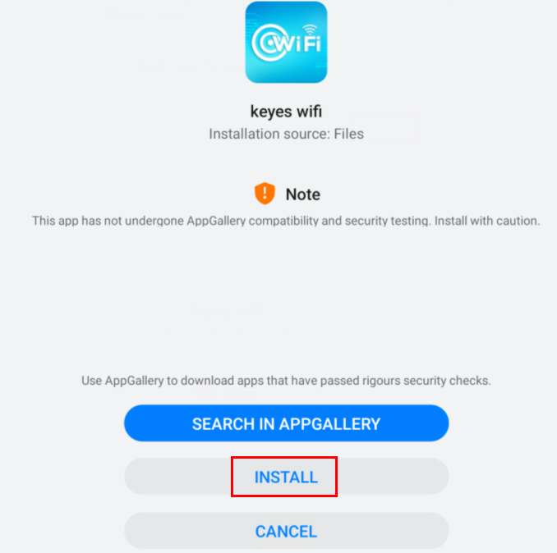

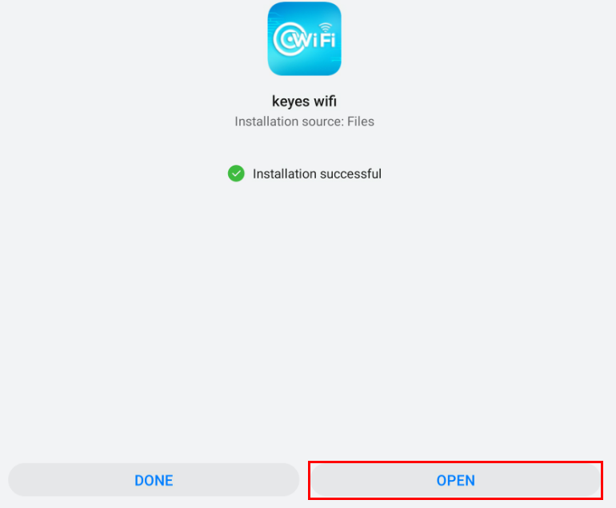

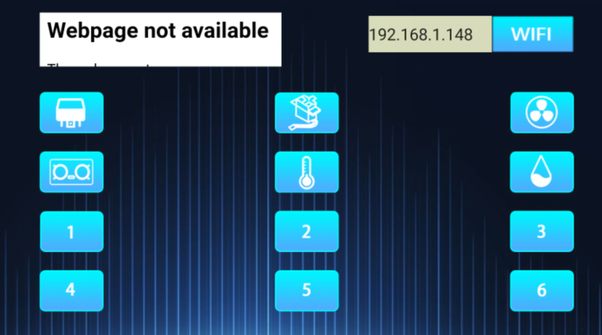

**iOS System**

1. Open App Store



Search keyes wifi to download.